Calculus 1 Lecture 1.1: An Introduction to Limits
Two goals for Calculus

1. Find the slope of a point on a curve
    - Find the tangent to a curve at a point

- Find the area under a curve between two points

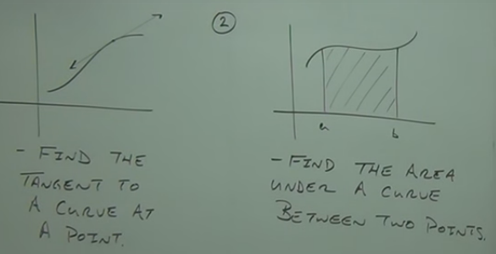

Tangent Problem
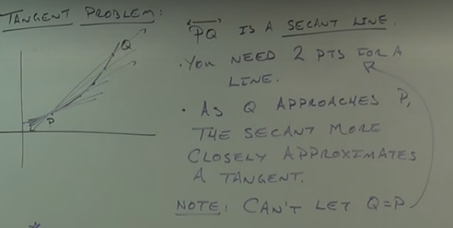

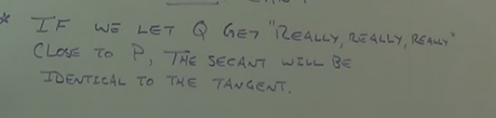



Example
Find the equation of the tangent line to 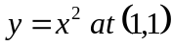

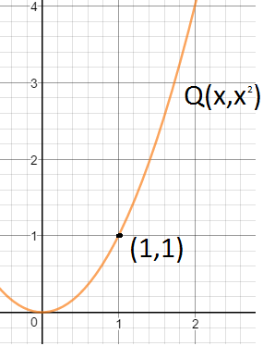

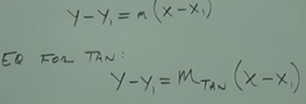
Note 1
As 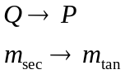
Note 2
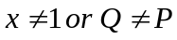

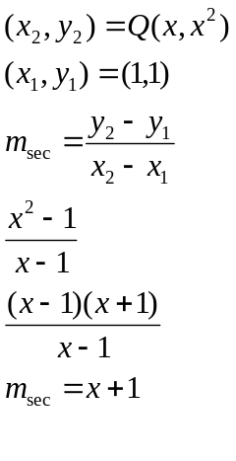

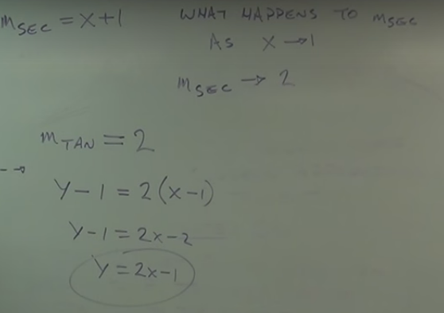

Definition of a Limit
What does the function do as the variable approaches a given value?

In General
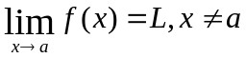

Example
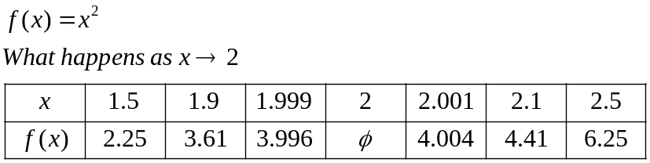
The function must approach the same number from the right and the left for the limit to exist
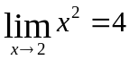

Example
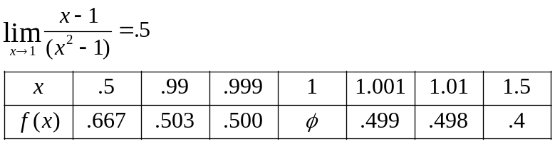

One sided limits

a one-sided limit is either of the two limits of a function f(x) of a real variable x as x approaches a specified point either from below(left) or from above(right)

Right sided limit 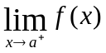
Left sided limit 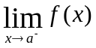

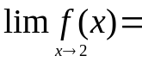Does not exist
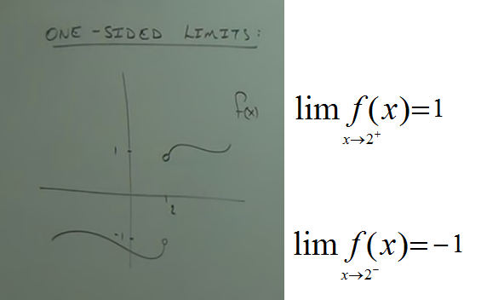

NOTE for a limit to exist at “a”
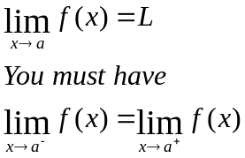

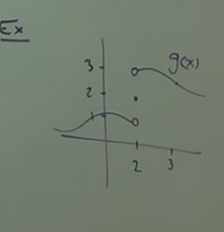

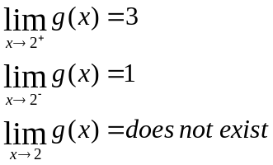

Find the values of the limits and find out if the general limit exists

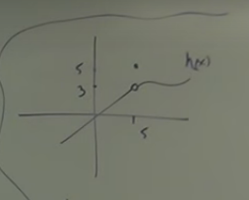

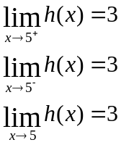

Example
Find the limit of 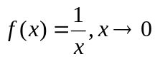
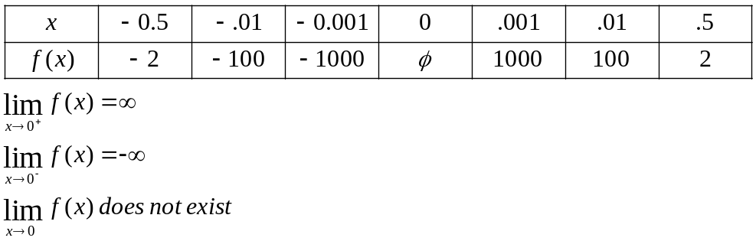

NOTE
